Water Quality Prediction using Statistical,Ensemble and Hybrid models

Vyshali S Vikram V Shriya B

SSN College of Engineering, Chennai

March 31, 2022


Objective- analyse the data and predict the water quality of the resources by building a model with better prediction ability.
Proposed Hybrid system- combination of statistical and ensemble learning models.
Statistical model- pre-processes the data set in order to resolve the shortcomings of real world data. Statistical techniques to be studied- Linear Regression, Classification, and Unsupervised Learning Algorithms.


Initially proposed to use and compare base models in Machine Learning and Statistics, then combine the best model from both to propose a hybrid model.
Received a feedback to try out ensembling the proposed models
Advised to bring out better predictability for the proposed hybrid model, to provide a positive thesis

Ensemble- create multiple models and combine them to produce better results.
Ensemble methods used: Bagging, Boosting and Stacking.
Base models: Decision tree classifier, random forest, XGboost, K neighbours and logistic regression.

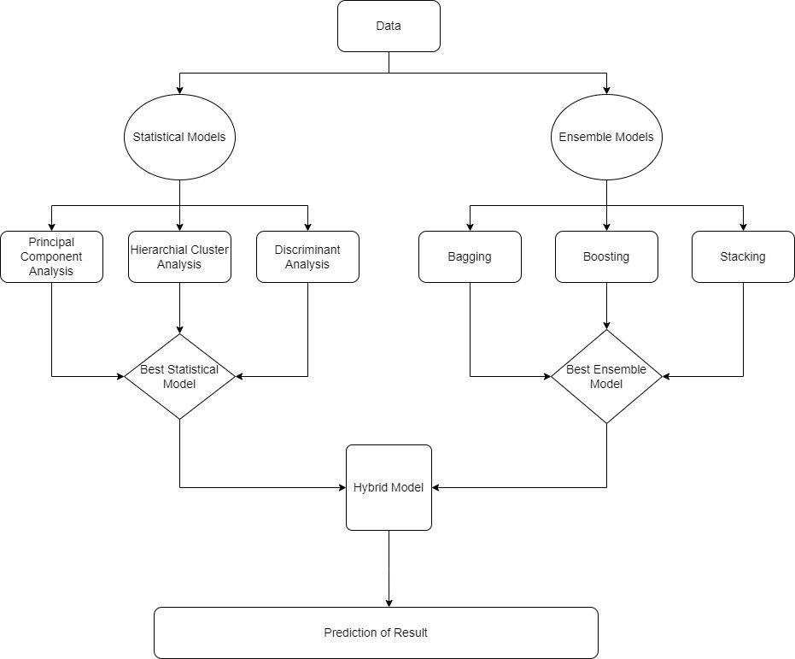

Base models :
Decision tree :- tree like model ; branches-decision rules ; leaf nodes-outcomes
Random Forest: combines outcomes of several small decision trees
XGBoost :- parallel tree boosting ; uses loss function to identify shortcomings of weak learners
K-neighbours - likelihood of belonging to one group based on proximity
Logistic regression :- predict a dependent categorical target variable ; only applicable to binary classification

Ensemble Techniques :
Bagging :- bootstrap aggregating ; decrease the variance in the prediction
Boosting :- combines a set of weak learners into a strong learner to minimize training errors
Stacking :- ensemble multiple classifications or regression models ; produce one optimal predictive model ; better performance than the base learners taken alone

Selected ensemble models to explore
Selected base models for Bagging, Boosting and Stacking
Built and trained the models with both binary and multi class data and found the best models
Binary class data - Adaboost[decision tree classifier] boosting model Multi class data - Decision tree classifier based bagging model

Ensemble learning is a machine learning paradigm where multiple models (often called “weak learners”) are trained to solve the same problem and combined to get more accurate and/or robust models.
A low bias and a low variance, are the two most fundamental features expected for a model. This is the called bias-variance trade-off.
The idea of ensemble methods is to try reducing bias and/or variance of such weak learners by combining several of them together in order to create a strong learner that achieves better performances.

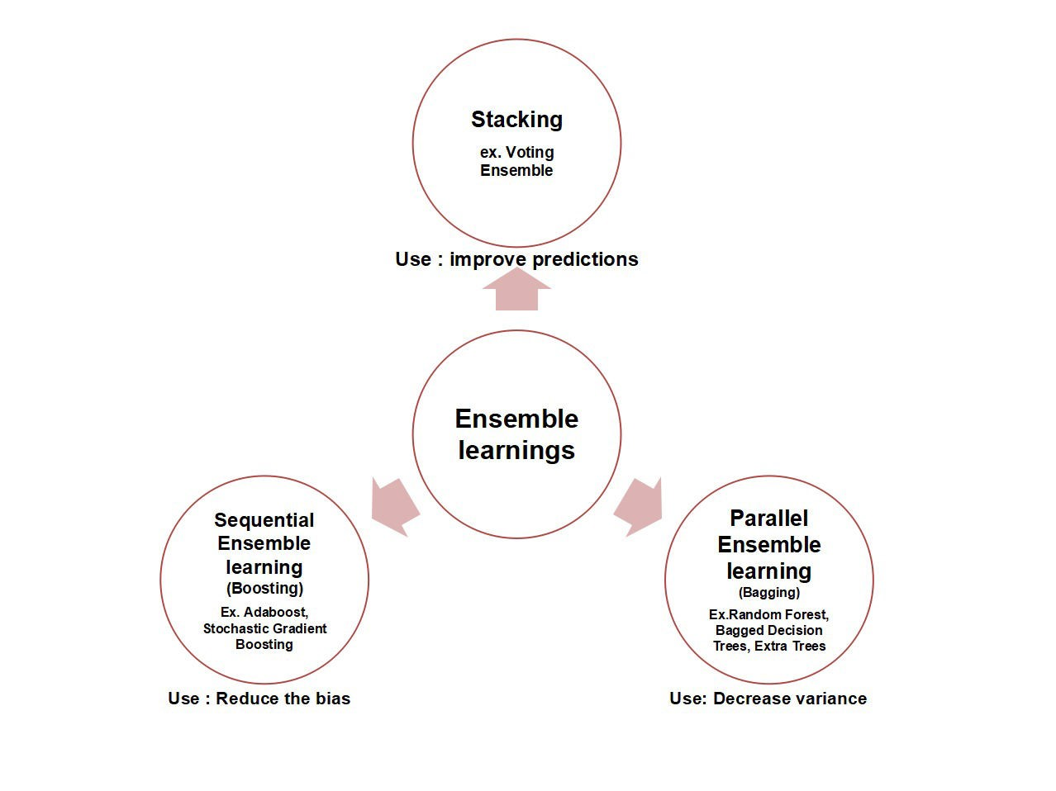

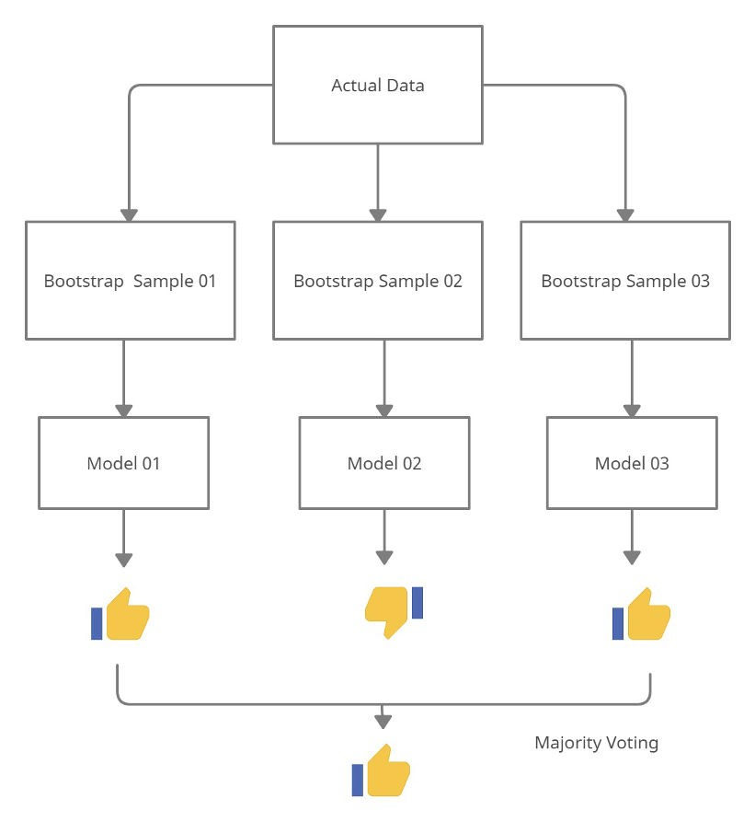

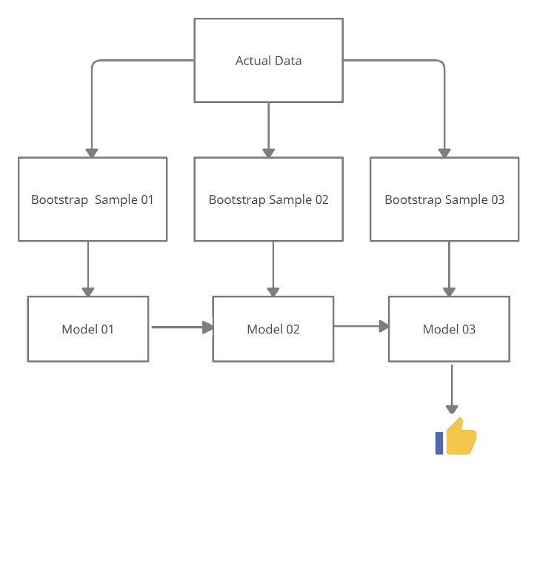

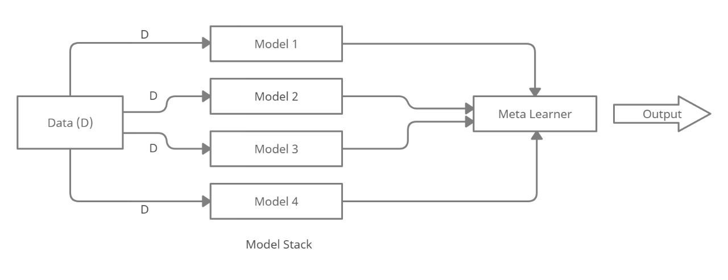

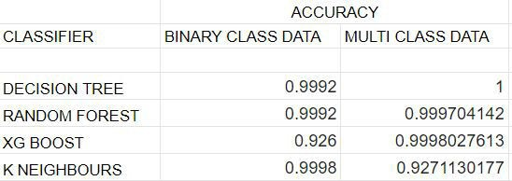

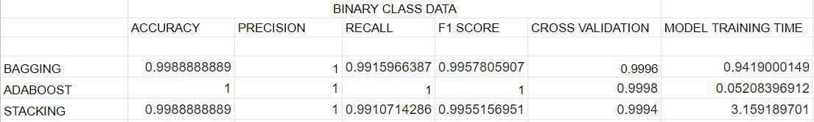

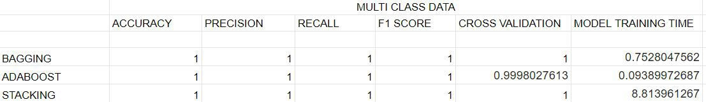

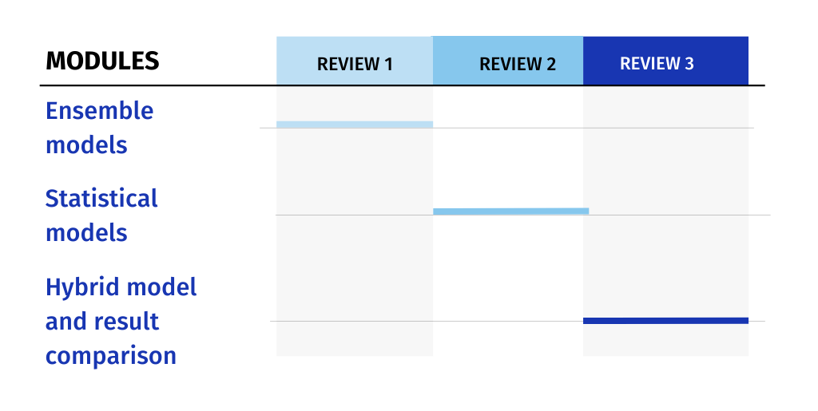

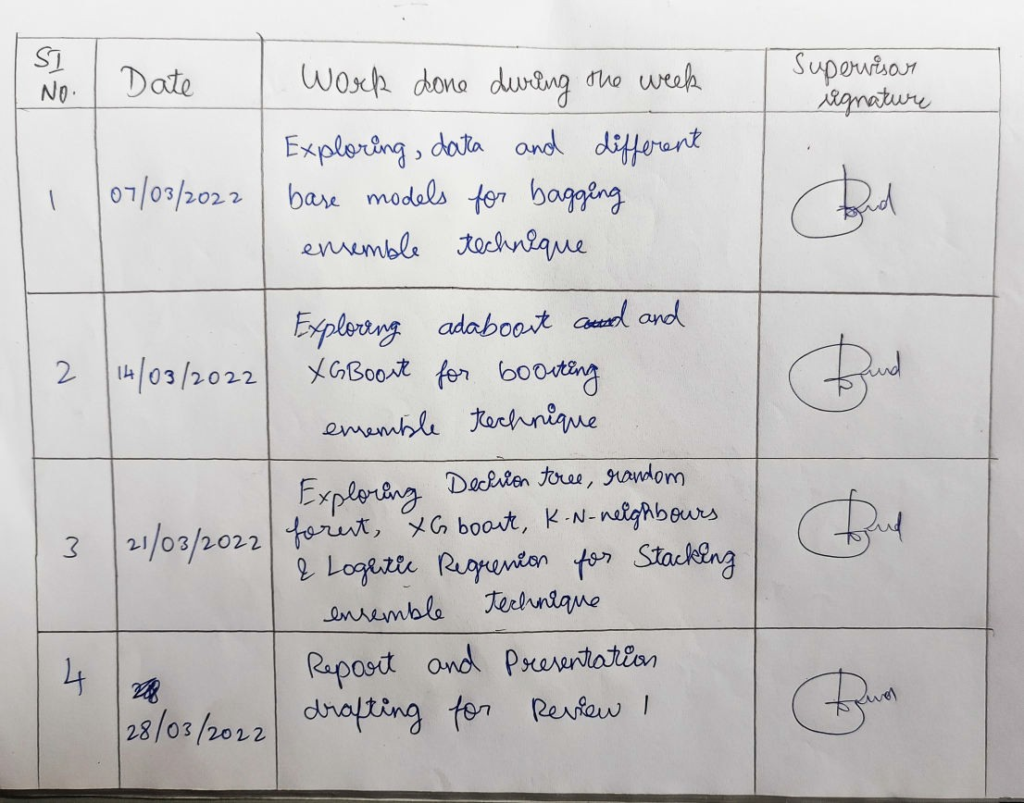

Thank You

